Name : Pragati Ghorpade
PRN : 202501050030

Practical 5
1)
Program :
import matplotlib.pyplot as plt
import pandas as pd

# Data for Months and Temperature for three cities
data = {
'Month': ['January', 'February', 'March', 'April', 'May', 'June', 'July', 'August', 'September', 'October', 'November', 'December'],
'City_A_Temperature': [5, 7, 10, 13, 17, 20, 22, 21, 18, 12, 8, 6],
'City_B_Temperature': [2, 3, 5, 6, 10, 14, 16, 17, 12, 9, 5, 3],
'City_C_Temperature': [3, 4, 6, 8, 9, 12, 15, 14, 10, 7, 4, 2]
}

# Write your code...
df = pd.DataFrame(data)

plt.stackplot(df['Month'],df['City_A_Temperature'],df['City_B_Temperature'],df['City_C_Temperature'])

plt.xlabel('Month')
plt.ylabel('Temperature')
plt.title('Temperature Variation')
plt.legend(loc='upper left')
plt.show()#
Output :
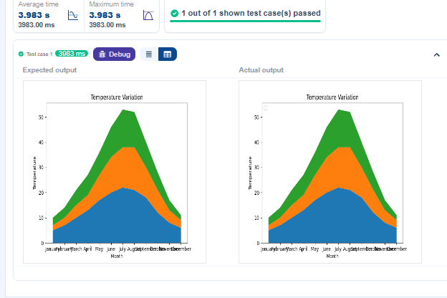
2)
Program :
import pandas as pd
import matplotlib.pyplot as plt

# Load the Titanic dataset
data = pd.read_csv('Titanic-Dataset.csv')

# Data Cleaning
data['Age'].fillna(data['Age'].median(), inplace=True)
data['Embarked'].fillna(data['Embarked'].mode()[0], inplace=True)
data.drop('Cabin', axis=1, inplace=True)

# Convert categorical features to numeric
data['Sex'] = data['Sex'].map({'male': 0, 'female': 1})
data = pd.get_dummies(data, columns=['Embarked'], drop_first=True)

# Write your code here for Histogram
plt.hist(data['Age'],bins=30, edgecolor='k')

plt.title('Age Distribution')

plt.xlabel('Age')

plt.ylabel('Frequency')

plt.show()
Output :
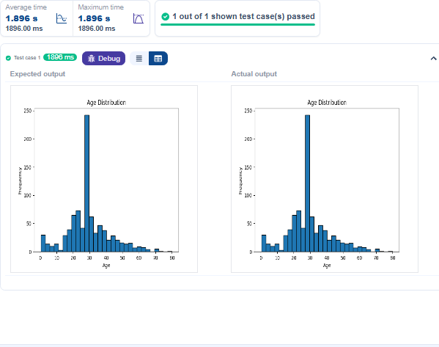

3)
Program :
import pandas as pd
import matplotlib.pyplot as plt

# Load the Titanic dataset
data = pd.read_csv('Titanic-Dataset.csv')

# Data Cleaning
data['Age'].fillna(data['Age'].median(), inplace=True)
data['Embarked'].fillna(data['Embarked'].mode()[0], inplace=True)
data.drop('Cabin', axis=1, inplace=True)

# Convert categorical features to numeric
data['Sex'] = data['Sex'].map({'male': 0, 'female': 1})
data = pd.get_dummies(data, columns=['Embarked'], drop_first=True)

# Write your code here for Bar Plot for Survival Rate
survival_counts=data['Survived'].value_counts()

survival_counts.plot(kind='bar')

plt.title('Survival Count')

plt.xlabel('Survived')

plt.ylabel('Count')

plt.show()
Output :
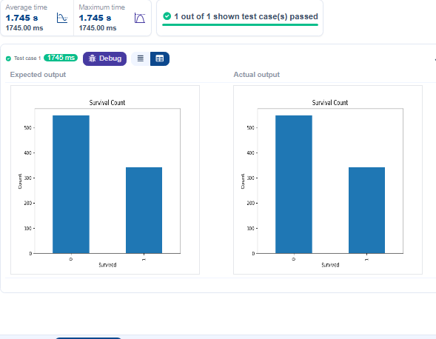
4)
Program :
import pandas as pd
import matplotlib.pyplot as plt

# Load the Titanic dataset
data = pd.read_csv('Titanic-Dataset.csv')

# Data Cleaning
data['Age'].fillna(data['Age'].median(), inplace=True)
data['Embarked'].fillna(data['Embarked'].mode()[0], inplace=True)
data.drop('Cabin', axis=1, inplace=True)

# Convert categorical features to numeric
data['Sex'] = data['Sex'].map({'male': 0, 'female': 1})
data = pd.get_dummies(data, columns=['Embarked'], drop_first=True)

# Write your code here for Bar Plot for Survival by Gender
grouped=data.groupby('Sex')['Survived'].value_counts().unstack()
grouped.plot(kind='bar',stacked=True)
plt.title('Survival by Gender')
plt.xlabel('Gender')
plt.ylabel('Count')
plt.legend(['Not Survived','Survived'])
plt.show()

Output :
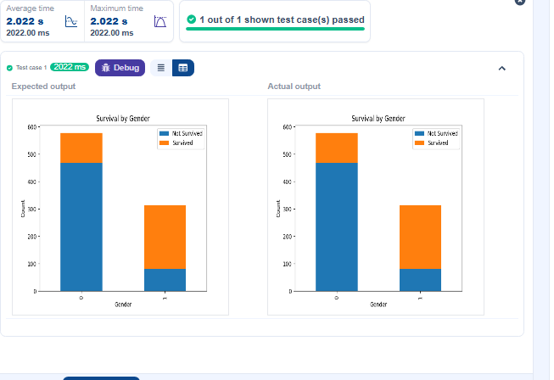
5)
Program :
import pandas as pd
import matplotlib.pyplot as plt

# Load the Titanic dataset
data = pd.read_csv('Titanic-Dataset.csv')

# Data Cleaning
data['Age'].fillna(data['Age'].median(), inplace=True)
data['Embarked'].fillna(data['Embarked'].mode()[0], inplace=True)
data.drop('Cabin', axis=1, inplace=True)

# Convert categorical features to numeric
data['Sex'] = data['Sex'].map({'male': 0, 'female': 1})
data = pd.get_dummies(data, columns=['Embarked'], drop_first=True)

# Write your code here for Bar Plot for Survival by Pclass
grp=data.groupby("Pclass")["Survived"].value_counts().unstack()

grp.plot(kind="bar",stacked="True")
plt.xlabel("Pclass")

plt.ylabel("Count")

plt.title("Survival by Pclass")

plt.legend(["Not Survive ","Survived"])
plt.show()
Output :
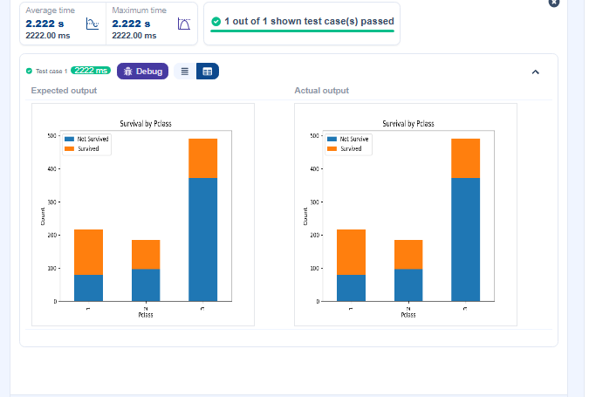

6)
Program :
import pandas as pd
import matplotlib.pyplot as plt

# Load the Titanic dataset
data = pd.read_csv('Titanic-Dataset.csv')

# Data Cleaning
data['Age'].fillna(data['Age'].median(), inplace=True)
data['Embarked'].fillna(data['Embarked'].mode()[0], inplace=True)
data.drop('Cabin', axis=1, inplace=True)

# Convert categorical features to numeric
data['Sex'] = data['Sex'].map({'male': 0, 'female': 1})
data = pd.get_dummies(data, columns=['Embarked'], drop_first=True)

# Write your code here for Bar Plot for Survival by Embarked
grp=data.groupby("Embarked_Q")["Survived"].value_counts().unstack()

grp.plot(kind="bar",stacked="True")

plt.legend(["Not Survived", "Survived"])

plt.ylabel("Counts")

plt.xlabel("Embarked")

plt.title("Survival by Embarked")

plt.show()
Output :
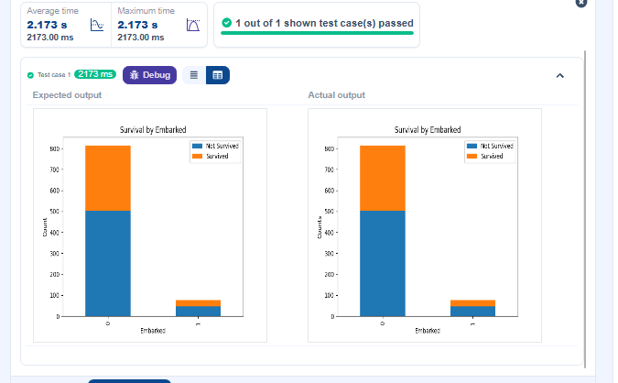

7)
Program :
import pandas as pd
import matplotlib.pyplot as plt

# Load the Titanic dataset
data = pd.read_csv('Titanic-Dataset.csv')

# Data Cleaning
data['Age'].fillna(data['Age'].median(), inplace=True)
data['Embarked'].fillna(data['Embarked'].mode()[0], inplace=True)
data.drop('Cabin', axis=1, inplace=True)

# Convert categorical features to numeric
data['Sex'] = data['Sex'].map({'male': 0, 'female': 1})
data = pd.get_dummies(data, columns=['Embarked'], drop_first=True)

# Write your code here for Box Plot for Age by Pclass

data.boxplot(column = 'Age', by='Pclass')
plt.title('Age by Pclass')
plt.suptitle(' ')
plt.xlabel('Pclass')
plt.ylabel('Age')
plt.show()
#
Output :
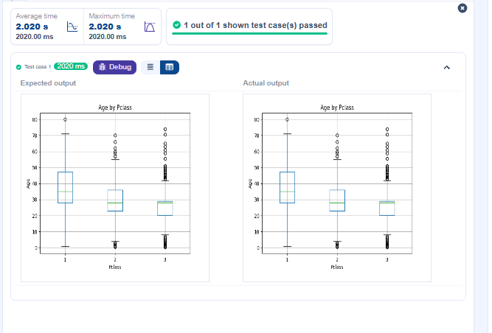

8)
Program :
import pandas as pd
import matplotlib.pyplot as plt

# Load the Titanic dataset
data = pd.read_csv('Titanic-Dataset.csv')

# Data Cleaning
data['Age'].fillna(data['Age'].median(), inplace=True)
data['Embarked'].fillna(data['Embarked'].mode()[0], inplace=True)
data.drop('Cabin', axis=1, inplace=True)

# Convert categorical features to numeric
data['Sex'] = data['Sex'].map({'male': 0, 'female': 1})
data = pd.get_dummies(data, columns=['Embarked'], drop_first=True)

# Write your code here for Box Plot for Age by Survived

plt.figure(figsize=(8,6))
data.boxplot(column='Age',by='Survived')
plt.title('Age by Survival')
plt.suptitle(' ')
plt.xlabel('Survived')
plt.ylabel('Age')
plt.show()

Output :
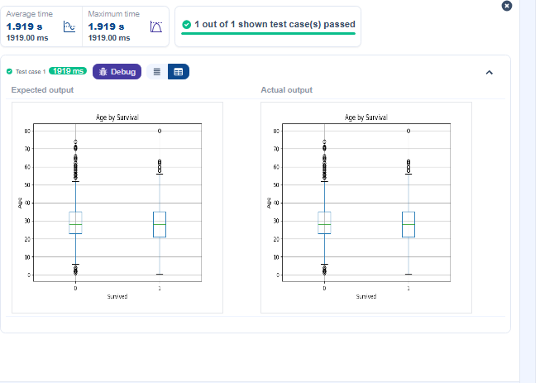
9)
Program :
import pandas as pd
import matplotlib.pyplot as plt

# Load the Titanic dataset
data = pd.read_csv('Titanic-Dataset.csv')

# Data Cleaning
data['Age'].fillna(data['Age'].median(), inplace=True)
data['Embarked'].fillna(data['Embarked'].mode()[0], inplace=True)
data.drop('Cabin', axis=1, inplace=True)

# Convert categorical features to numeric
data['Sex'] = data['Sex'].map({'male': 0, 'female': 1})
data = pd.get_dummies(data, columns=['Embarked'], drop_first=True)

# Write your code here for Box Plot for Fare by Pclass

data.boxplot(column='Fare',by='Pclass')

plt.title('Fare by Pclass')
plt.suptitle('')
plt.xlabel('Pclass')
plt.ylabel('Fare')
plt.show()
Output :
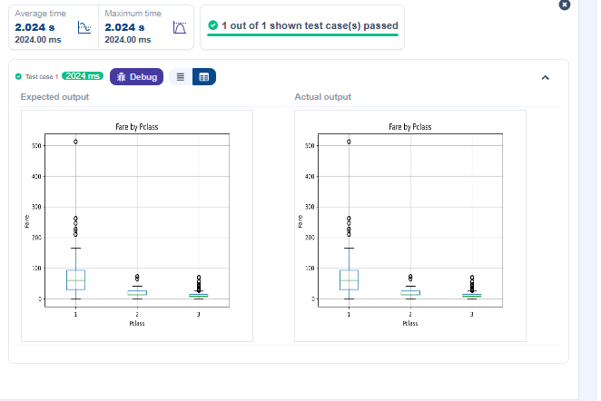

10)
Program :
import pandas as pd
import matplotlib.pyplot as plt

# Load the Titanic dataset
data = pd.read_csv('Titanic-Dataset.csv')

# Data Cleaning
data['Age'].fillna(data['Age'].median(), inplace=True)
data['Embarked'].fillna(data['Embarked'].mode()[0], inplace=True)
data.drop('Cabin', axis=1, inplace=True)

# Convert categorical features to numeric
data['Sex'] = data['Sex'].map({'male': 0, 'female': 1})
data = pd.get_dummies(data, columns=['Embarked'], drop_first=True)

# Write your code here for Box Plot for Fare by Pclass
plt.scatter(data['Age'],data['Fare'])

plt.title("Age vs. Fare")
plt.xlabel("Age")
plt.ylabel("Fare")
plt.show()

Output :
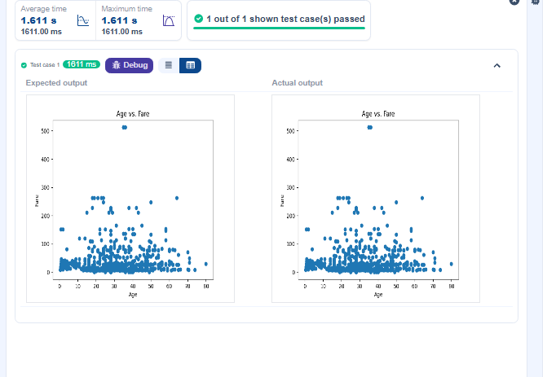
11)
Program :
import pandas as pd
import matplotlib.pyplot as plt

# Load the Titanic dataset
data = pd.read_csv('Titanic-Dataset.csv')

# Data Cleaning
data['Age'].fillna(data['Age'].median(), inplace=True)
data['Embarked'].fillna(data['Embarked'].mode()[0], inplace=True)
data.drop('Cabin', axis=1, inplace=True)

# Convert categorical features to numeric
data['Sex'] = data['Sex'].map({'male': 0, 'female': 1})
data = pd.get_dummies(data, columns=['Embarked'], drop_first=True)

# Write your code here for Scatter Plot for Age vs. Fare by Survived

colors=data['Survived'].map({0: 'red',1: 'blue'})
plt.scatter(data['Age'],data['Fare'],c=colors)

plt.title("Age vs. Fare by Survival")
plt.xlabel('Age')
plt.ylabel('Fare')
plt.show()
Output :
